**Task 1 Responsiveness Analysis:**

When it comes to creating a responsive webpage two important factors are using the

Metaname "viewport" command know as:

"<meta name="viewport" content="width=device-width, initial-scale=1">"

Using this command tells the page to match the device screen width with "device-independent" pixels. This makes easy for the page to resize itself to match different screen sizes whether it be on a PC, tablet, or mobile phone.

One example of Responsive Webpage is this Automotive Mechanics Page:





This Automotive repair website is an example of a website that is responsive to a user. For example, when the user drags the browser window around, we can see that the webpage adapts and changes to the different sizing requirements of the user. Allow them to get the same experience from the page just in a different size window.

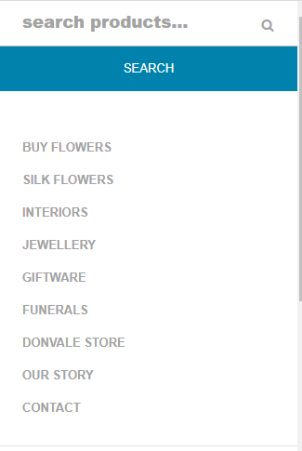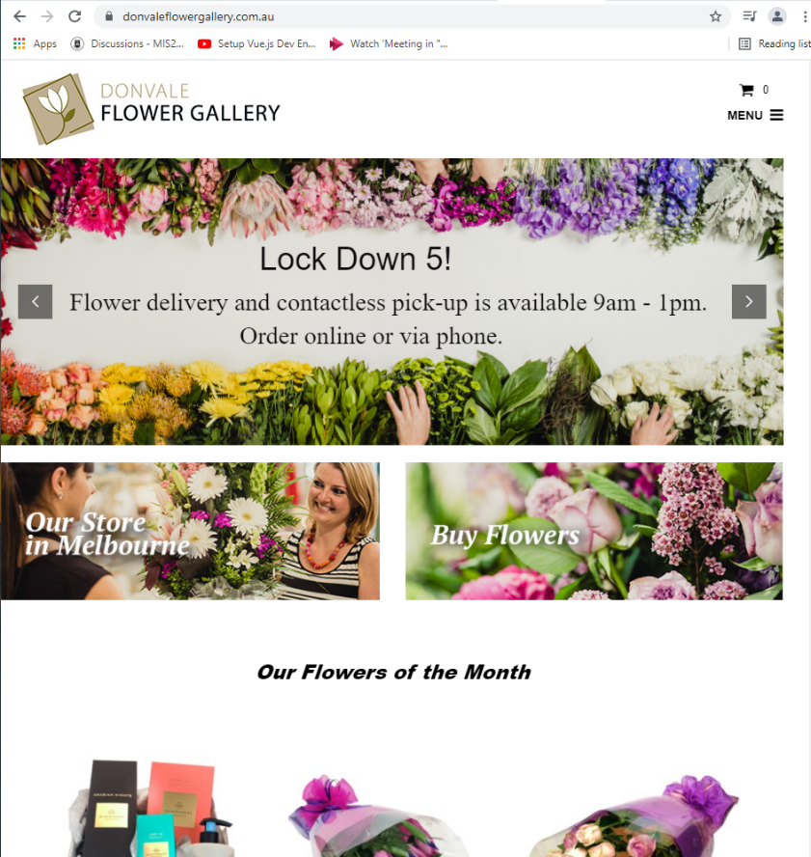

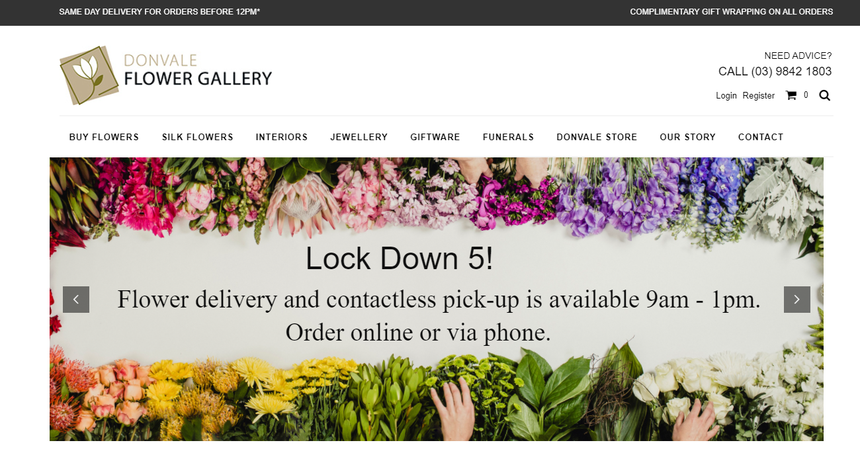

Another example of a dynamic and responsive webpage is this Flower Gallery page. Here we can see many examples of responsive aspects such as the flexible images which change sizes based on the browser window sizes of the user and another includes the dynamic menu changes when the user hits the breaking point off the website allowing the user to select different subpages of the site by click on the menu button on the right side of the page. It is important to note that this subpage bar is typically on the topic of the page when user has not hit the break point of the site.

**User Stories:**

|  |  |
| --- | --- |
| As a user I want to be able to make a booking for a Tour | * 1. User must a keyboard (either physical or Onscreen) to enter text into a text box.   2. User must be able to use a mouse to select the date they wish to visit.      * 1. User must enter:      + First Name      + Last Name      + Date of Birth      + Address      + Email Address      + Payment information      * 1. User must be able to confirm when they're happy with their inputs. |
| As a user I wish to wish to cancel my booking for a Tour previously booked. | * 1. User must be able to operate a mouse or keyboard   2. User must be able navigate to the "Tours" page.   3. User must find their booking and click cancel   4. User must confirm their cancelation. |
| I wish for the website to accommodate multiple device screens. | * 1. Website should be able to recognize which device it is being displayed on.      * 1. Webpage should display content correctly according to the dimensions of the device screen. |
| As a user I want to be able to view the Gallery page. | * 1. User make be able to use a mouse or keyboard to select hyperlinks on screen.      * 1. Website must display gallery webpage to user. |